Başkent University
Department of Electrical and Electronics Engineering
EEM 311 Electronics II

Experiment 11

RC PHASE-SHIFT OSCILLATORS

Theory

Oscillator circuits can be built using opamps with feedback to phase-shift the output signal by 180º. Phase-shift: In a phase-shift oscillator, as shown in Figure 1 three sections of resistor-capacitor are used. The resulting oscillator frequency can be calculated using

f=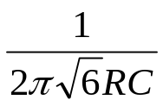

For the opamp to cause the circuit to oscillate requires that the op-amp gain be of magnitude 29.

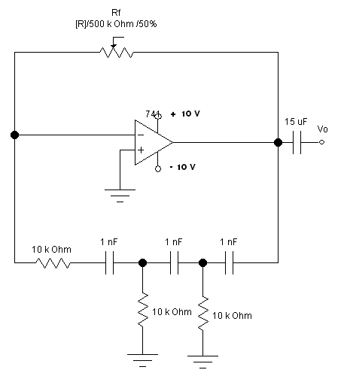
R1
Figure 1.

Preliminary Work

Construct the circuit in Figure1. And record the output waveform of the oscillator circuit.

Procedure

- Construct the circuit of Figure 1 with a Rf= 500 K potentiometer, R1=22 K, R=100 K and C=1 nF. (Measure and record resistor values in Figure 1 )
- Use the oscilloscope to record the output waveform of the oscillator circuit. Adjust Rf for maximum undistorted output waveform Vo. Record value of rf for this undistorted condition.
- Measure and record the time for one cycle of the waveform.
- Determine the frequency of the waveform.
- Replace the capacitors with C=10 nF and repeat steps 3-4.
- Calculate the theoretical frequency using the equation in theory part.
- Compare the measured and calculated frequency for both capacitors.

Experiment List

- 741 op-amp
- 2-DC power supplies (±10V)
- Analog signal generator
- Resistors: 1*22K, 2*100K
- Potentiometer: 1*500 K
- Capacitors: 1* 15 µF, 3* 1 nF, 3*10 nF

References

Electronic Devices and Circuit Theory, Sixth Edition, Robert L. Boylestad, Louis Nashelsky.

REPORT

1.
Vin
Vout

Rf = ........

2. T = .......

3. f = 1/T f = .......

4. T2 = .......

F = .........

5. f (calculated) =....................

f2(calculated) = .................

6. Commands:

